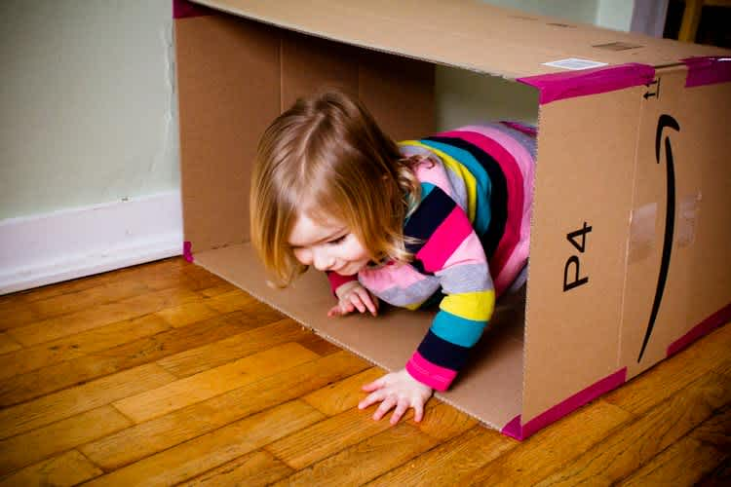

ACTIVITIES AND LINKS TO KEEP YOUR LITTLE ONES HAVING FUN WHILE THEY ARE AT HOME.

**PLAY** &

LEARN

Join the #RainbowTrailAustralia

to share love and support during these uncertain times.

Post your photos on our Facebook Group!

**ACTIVITIES AND LINKS TO KEEP YOUR LITTLE ONES HAVING FUN WHILE THEY ARE AT HOME.**

*Image from sparklestories.com*

PLAYDOUGH  
Having play dough on hand makes a wonderful no prep activity. Buy some or make your own! Add trucks and tractors, cookie cutters, bowls, patty pans. It really is a limitless and much-loved activity.

CAR/BIKE WASH  
Make believe play is a lot of fun! Fill a bucket of water, put out some sponges and small towels. And line up your children’s bikes and or play cars. It’s wash time. If you happen to have a play cash register, set that up on a table too it will add to the fun.

PUT ON SOME MUSIC

Yes, you might get a few requests but dancing is a much-loved pastime. Try searching YouTube or Spotify for ‘Super Simple Songs’ their most loved movie soundtrack or try the Kinderling app or digital radio station for Pre-school shows and playlists.

INDOOR OBSTACLE COURSE

Look around the house for everyday items you might be able to use chairs, pillows, socks, baskets, towels rolled up…  
Make the obstacle course simple at first and change the stations as they're mastered. If you like, time the kids to see who can complete the course fastest. Just beware, it can quickly turn competitive! Here are a few ideas to get you started on building an indoor obstacle course for your kids:

1. Crawl under or over a row of chairs

2. Crawl under a string stretched between two chair legs  
3. Walk along a rolled-up towel like a balance beam  
 *familyeducation.com*

BUCKETS AND SOCKS  
Rolled up socks and buckets can be all you need for a lot of fun. Start with the bucket not too far away and try to throw the socks into the bucket. Once that is mastered move it further away. Challenge your children, ask them to try throwing with the opposite hand than they usually use, with their eyes closed.

COLOUR SCAVENGER HUNT

This could be an indoor or an outdoor activity. It is also a great one to use while prepping dinner. Ask your child to find an object for every colour of the rainbow. Or, be more specific and ask them to find a red block, a yellow ball etc.

Ensuring the health, safety and wellbeing of children and staff is our priority. Should your child not be able to attend our service due to illness or infectious disease, these Play & Learn suggestions may come in handy. Thank you for your support and understanding during this evolving COVID-19 crisis. Please be assured that Open Arms EEC is taking every possible measure to help slow the spread of this virus. – Alyssa Wood

**QUICK SET UP ACTIVITIES**



SCHOLASTIC LEARN AT HOME

Scholastic *Learn at Home* provides 20 days’ worth of active learning journeys designed to reinforce and sustain educational opportunities.

[classroommagazines.scholastic.com/support/learnathome/grades-prek-k.html](http://classroommagazines.scholastic.com/support/learnathome/grades-prek-k.html)  
  
KIWICO AT HOME ACTIVITIES

KiwiCo have created a great library of at home STEAM activities [www.kiwico.com/blog/2020/03/14/activities-for-2-4-year-olds-at-home/](https://www.kiwico.com/blog/2020/03/14/activities-for-2-4-year-olds-at-home/)

KIDSPOT   
At kidspot you’ll find a range of activities like arts & crafts, science experiments and brain teasers to outdoor games like hide & seek.

[kidspot.com.au/things-to-do/collection/games-crafts-and-activities-for-3-4-year-olds](http://kidspot.com.au/things-to-do/collection/games-crafts-and-activities-for-3-4-year-olds)

HANDS ON AS WE GROW

Has a huge range of FREE resources for all age groups.

[handsonaswegrow.com/samples-weekly-activities-planner/play-week/](http://handsonaswegrow.com/samples-weekly-activities-planner/play-week/)



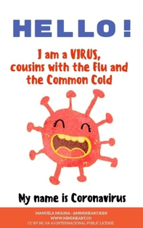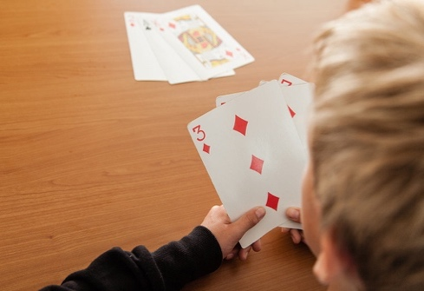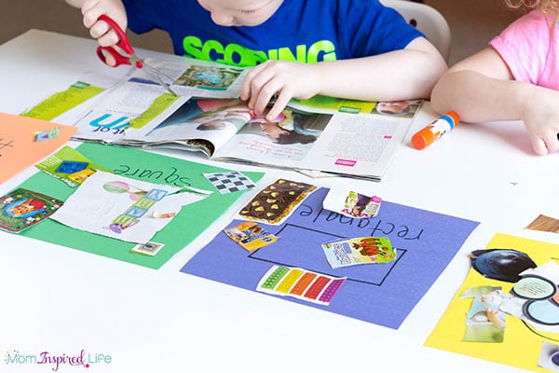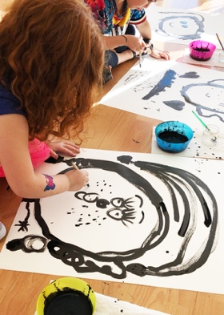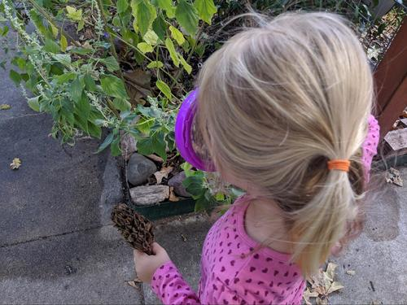

please do not allow your child to attend open arms eec if they show any signs of being unwell.

Open Arms EEC will require a medical clearance letter for your child to return to care if they are sent home due to illness or exhibits any signs associated with COVID-19.

Our exclusion periods as per our policies are:

* 48 hours after the last vomit / diarrhoea
* 24 hours from the last temperature recorded
* 24 hours after visible signs of infection eg rattling chest / green snot / shivering / coughing

Under NO circumstances should a child attend if they have been given Panadol or Nurofen

This PDF is written especially for young children and explains COVID-19 very simply.

[mindheart.co/descargables](http://mindheart.co/descargables)

**GOOD HYGIENE**

Preschool aged children love to investigate. Help them see the germs by trying out this **experiment.** [www.fantasticfunandlearning.com/make-germs-scatter-science-demonstration.html](http://www.fantasticfunandlearning.com/make-germs-scatter-science-demonstration.html)

**Remind, demonstrate and sing!**

**Wash your hands song** [www.youtube.com/watch?v=_02FuyeCWFU](https://www.youtube.com/watch?v=_02FuyeCWFU)

**Cover your cough with a tissue or your elbow.** After coughing or sneezing always wash your hands.

**Wash your hands** with soap for at least 20 seconds or the time it takes to sing **Twinkle Twinkle Little Star**

**PLAY CARDS**  
(Resource: pack of cards)

Teach your kids your favourite card game, perhaps a simple one such as **UNO** or **donkey**, where everyone each gets a card and must follow the pattern on the card left open in the deck. If it is a 3 of hearts, everyone will need to play hearts and whoever plays the highest number wins the hand. *parenting.firstcry.com*

**LOOK CLOSER**

(Resource: Magnifying glass)

Give your child a magnifying glass and let them explore the house. Everything looks very different up close. Head outside and look closer at plants and bugs.

**MAGAZINE SHAPE HUNT**

(Resource: Magazines, safe scissors, glue stick, paper, markers)

* Draw basic shapes on separate pieces of paper.
* Together find a couple of shapes in a magazine, cut them out and match them with the correct blank shape sheet. Then let your child search on their own. *funlearningforkids.com*

p

**SELF PORTRAIT**  
(Resource: Paper, black paint, crayons, mirror)

* Set up a paint space with a mirror. Ask your child to paint what they see. They might do many versions of their portrait.
* Let the painting dry, and now colour it in with crayons. *mericherry.com*

**ACTIVITIES WITH MINIMAL   
RESOURCES**

**It is a confusing time for our children. They can sense something is different but don’t really understand what is going on. Talking with your children and ensuring they feel safe is important.**

**UNDERSTANDING COVID-19**