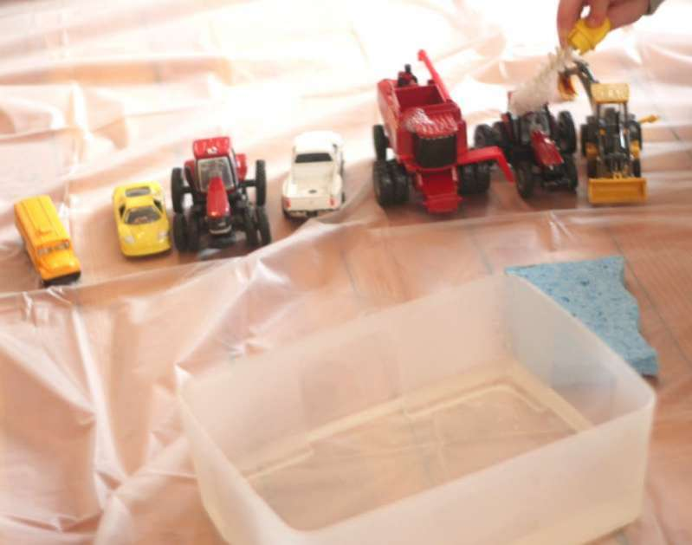

**PLAY** &

LEARN

ACTIVITIES AND LINKS TO KEEP YOUR LITTLE ONES HAVING FUN WHILE THEY ARE AT HOME.

Join the #RainbowTrailAustralia

to share love and support during these uncertain times.

Post your photos on our Facebook Group!

Ensuring the health, safety and wellbeing of children and staff is our priority. Should your child not be able to attend our service due to illness or infectious disease, these Play & Learn suggestions may come in handy. Thank you for your support and understanding during this evolving COVID-19 crisis. Please be assured that Open Arms EEC is taking every possible measure to help slow the spread of this virus. - Alyssa Wood

TODDLERS AND TONGS

Empty a box of blocks on the floor and give your child some tongs and different sized containers. Watch them move the blocks from one container to another. Toddlers love moving objects around, experimenting with filling containers and emptying them again. Using tongs adds an extra fine motor challenge.

TUB OF WATER

Water play is always a hit amongst young children. Children could wash their toys, transfer water from one container to another, experiment to find out which toys float and sink.   
  
SCAVENGER HUNT  
Give your child a bag and call out an object or describe an object and send them of to find it.   
  
CARDBOARD BOXES

Let their imagination run wild- maybe it’s a bus or a train, a spaceship? Cardboard boxes make great canvases too just add textas, crayons or pencils.

*Find more at handsonaswegrow.com*

PLAYDOUGH  
Having play dough on hand makes a wonderful no prep activity. Buy some or make your own! Add trucks and tractors, cookie cutters, bowls, patty pans. It really is a limitless and much-loved activity.   
  
PEGS AND A CLOTHESLINE

Use a clothes horse or hang a line between two chairs. Bring in your clothes pegs and give the kids the tea towels. It’s funny how much they love the activities we don’t.

PUT ON SOME MUSIC

Yes, you might get a few requests, but dancing is a much-loved pastime. Try searching YouTube or Spotify for ‘Super Simple Songs’ or ‘Little Baby Bum’ nursery rhymes, The Wiggles (always a favourite) or their most loved movie soundtrack.

**QUICK SET UP ACTIVITIES**



SCHOLASTIC LEARN AT HOME

Scholastic *Learn at Home* provides 20 days’ worth of active learning journeys designed to reinforce and sustain educational opportunities.

[classroommagazines.scholastic.com/support/learnathome/grades-prek-k.html](http://classroommagazines.scholastic.com/support/learnathome/grades-prek-k.html)  
  
KIWICO AT HOME ACTIVITIES

KiwiCo have created a great library of at home STEAM activities [www.kiwico.com/blog/2020/03/14/activities-for-2-4-year-olds-at-home/](https://www.kiwico.com/blog/2020/03/14/activities-for-2-4-year-olds-at-home/)

TEACHING 2 AND 3 YEAR OLDS   
This website has hundreds of engaging activities for 2-3 year old’s. Choose a theme and follow the link to simple activities your child will love.

[teaching2and3yearolds.com/category/toddlers/](http://teaching2and3yearolds.com/category/toddlers/)

HANDS ON AS WE GROW

Has a huge range of FREE resources for all age groups.

[handsonaswegrow.com/samples-weekly-activities-planner/play-week/](http://handsonaswegrow.com/samples-weekly-activities-planner/play-week/)

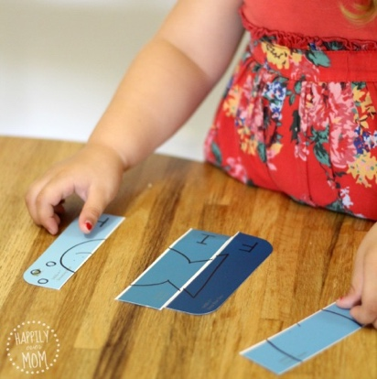

**CUTTING**  
(Resource: Kid safe Scissors, old magazines)

* Practicing scissor skills is an activity children enjoy doing over and over again.

**THE LITTLE ARTIST**  
(Resource: Paints, paper, brushes) Yes painting can be messy but it is lots of fun. You can create a stress free painting experience simply by restricting the painting environment. Attaching paper to an easel, taping to a window or using an inverted pizza box will help young ones understand the allowable paint space. Limiting choices of paints and brushes by no means limits fun it just creates boundaries. Enjoy.

**LOOK CLOSER**

(Resource: Magnifying glass)

* Give your child a magnifying glass and let them explore the house. Everything looks very different up close.
* Head outside and look closer at plants and bugs.

**PAINT CHIP CARDS**  
(Resource: Colour paint chip cards)

* Make a simple puzzle by cutting the paint card in two.
* Draw a simple picture on a paint card and cut along lines or make the activity harder by cutting zig-zags. *happilyevermom.com*

**ACTIVITIES WITH MINIMAL RESOURCES**

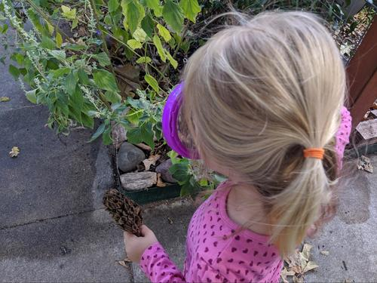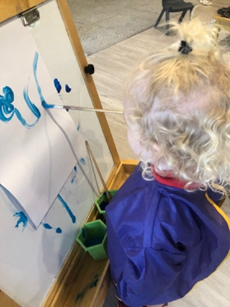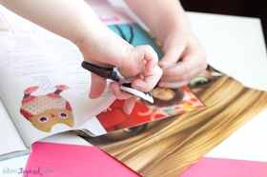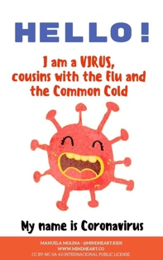

please do not allow your child to attend OPEN ARMS EEC if they show any signs of being unwell.

Open Arms EEC will require a medical clearance letter for your child to return to care if they are sent home due to illness or exhibiting any signs associated with COVID-19.

Our exclusion periods as per our policies are:

* 48 hours after the last vomit / diarrhoea
* 24 hours from the last temperature recorded
* 24 hours after visible signs of infection eg rattling chest / green snot / shivering / coughing

Under NO circumstances should a child attend if they have been given Panadol or Nurofen

This PDF is written especially for young children and explains COVID-19 very simply.

http://mindheart.co/descargables

**GOOD HYGIENE AND 2 YEAR OLDS**

2-3 year olds are very hands on encouraging them to not touch everything and then touch there face seems an impossible task.

Help them see the germs by trying out this **experiment.** [www.fantasticfunandlearning.com/make-germs-scatter-science-demonstration.html](http://www.fantasticfunandlearning.com/make-germs-scatter-science-demonstration.html)

**Remind, demonstrate and sing!**

**Wash your hands song** [www.youtube.com/watch?v=_02FuyeCWFU](https://www.youtube.com/watch?v=_02FuyeCWFU)

**Cover your cough with a tissue or your elbow.** After coughing or sneezing always wash your hands.

**Wash your hands** with soap for at least 20 seconds or the time it takes to sing **Twinkle Twinkle Little Star**

**It is a confusing time for our children. They can sense something is different but don’t really understand what is going on. Talking with your children and ensuring they feel safe is important.**

**UNDERSTANDING COVID-19**