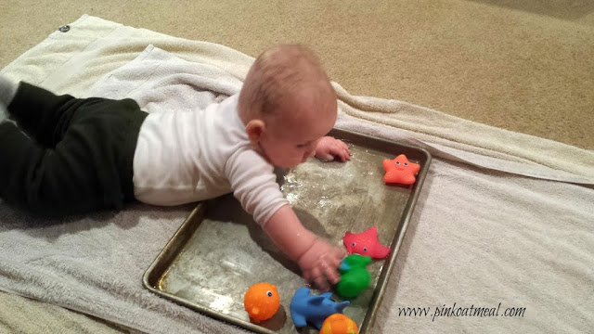p

PLAYDOUGH  
Having play dough on hand makes a wonderful no prep activity. Buy some or make your own! Add trucks and tractors, cookie cutters, bowls, patty pans. It really is a limitless and much-loved activity. Baby safe playdough recipe - *www.learning4kids.net/2014/11/11/edible-play-dough-recipe-babies/*

PUT ON SOME MUSIC

Yes, you might get a few requests but dancing is a much-loved pastime. Try searching YouTube or Spotify for ‘Super Simple Songs’ or ‘Little Baby Bum’ nursery rhymes, The Wiggles (always a favourite) or their most loved movie soundtrack.

**QUICK SET UP ACTIVITIES**

*Always supervise young children*

TRAY OF WATER

Fill a baking tray with water and add a bits and pieces. You could add toys or just basic safe kitchen items like spoons or measuring cups.

THE POT CUPBOARD  
Simply open the pot cupboard, make sure there is nothing unsafe and let your child play. Add a few wooden spoons if you’re up for the noise.   
  
CARDBOARD BOXES

Cardboard boxes are always a great idea, raid your cupboards and see how many varying sizes you can find. Place them on the floor alongside a basket of their toys. Babies love placing object in and taking them out of boxes  
  
PLASTIC CUPS

Give your child a collection of plastic cups. Show them how to make a tower, stack them together and then allow them to try and experiment.

Join the #RainbowTrailAustralia

to share love and support during these uncertain times.

Post your photos on our Facebook Group!

**PLAY** &

LEARN

ACTIVITIES AND LINKS TO KEEP YOUR LITTLE ONES HAVING FUN WHILE THEY ARE AT HOME.

Ensuring the health, safety and wellbeing of children and staff is our priority. Should your child not be able to attend our service due to illness or infectious disease, these Play & Learn suggestions may come in handy. Thank you for your support and understanding during this evolving COVID-19 crisis. Please be assured that Open Arms EEC is taking every possible measure to help slow the spread of this virus. – Alyssa Wood

kinderling   
Is there anything more magical than a great book? Kinderling has a huge library of recorded children’s books. Listen only or read along if you have the book at home.

[www.kinderling.com.au/stories](https://www.kinderling.com.au/stories)

HANDS ON AS WE GROW

Has a huge range of FREE resources for all age groups.

[handsonaswegrow.com/activities/baby-play/](http://handsonaswegrow.com/activities/baby-play/)



HELP MY KID LEARN

This website is packed full of activities for a range of age groups. Simply select 0-2 and choose a sub-category Talk, Play, Read, Write or Count.

<http://www.helpmykidlearn.ie>

KIDSPOT

Games, craft and activities for 0-1 year old’s. .[www.kidspot.com.au/things-to-do/collection/games-crafts-and-activities-for-0-1-year-olds](http://www.kidspot.com.au/things-to-do/collection/games-crafts-and-activities-for-0-1-year-olds)



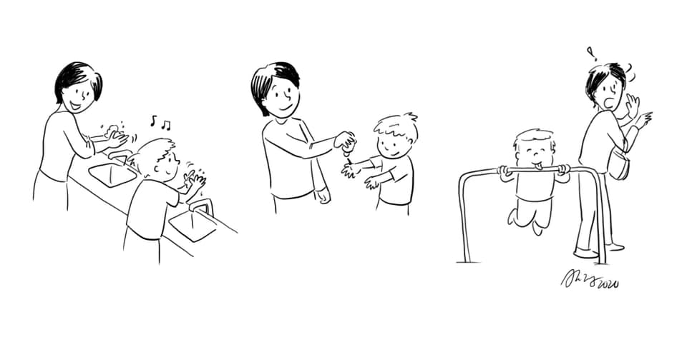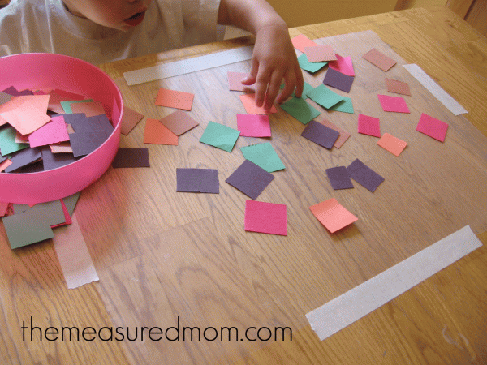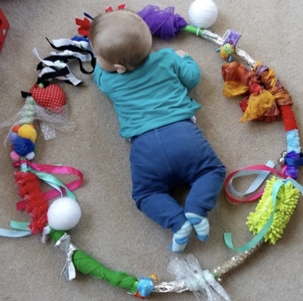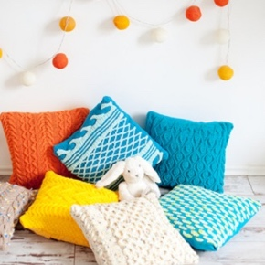

please do not allow your child to attend OPEN ARMS EEC if they show any signs of being unwell.

Open Arms EEC will require a medical clearance letter for your child to return to care if they are sent home due to illness or exhibits any signs associated with COVID-19.

Our exclusion periods as per our policies are:

* 48 hours after the last vomit / diarrhoea
* 24 hours from the last temperature recorded
* 24 hours after visible signs of infection eg rattling chest / green snot / shivering / coughing

Under NO circumstances should a child attend if they have been given Panadol or Nurofen

New Mum comics is great for that! Check out her Facebook page- new mom comics

**GOOD HYGIENE**Practise and demonstrate   
good hygiene.

**Wash your hands song** [youtube.com/watch?v=_02FuyeCWFU](http://youtube.com/watch?v=_02FuyeCWFU)

**Cover your cough with a tissue or your elbow.** After coughing or sneezing always wash your hands.

**Wash your hands** with soap for at least 20 seconds or the time it takes to sing **Twinkle Twinkle Little Star**

**It is a confusing time for our children. They can sense something is different but don’t really understand what is going on. Talking with your children and ensuring they feel safe is important.** Managing your own mental state is very important too. Don’t allow yourself to sit and constantly scroll your Facebook or Instagram feed and become overwhelmed by the huge amount of ‘news’ out there. Stick to the appropriate state health website in your area, WHO and trusted Australian government sites and limit your time there. Also don’t forget to laugh.

**BUBBLES AND BABIES**  
(Resource: Bubbles)

Bubbles is one of the simplest engaging activities for babies. Blow bubbles for your babe lying on your backs, tummies, sitting up.

**CONTACT PAPER CRAFT**  
(Resource: Contact paper, tape, cut up paper)

Peel off the backing paper and tape the contact down sticky side up. Give your child a bowl of cut up paper and show them how to stick the paper to the contact. Your child will enjoy sticking paper on and even pulling it back off over and over again. themeasuredmom.com

**SENSORY HOOLA HOOP**

(Resource: Hoola-hoop, material scraps, small toys, ribbons etc.)

Attach as many textured, colourful, and dangly things you can find around your hoola-hoop. Ensure everything is secure and not a choking risk. Place baby in the middle of the hoop on their tummy. Watch them move around the circle and interact with the objects.

**SOFT OBSTACLE COURSE**  
(Resource: Pillows, blankets…)

Crawling baby? Set up a soft obstacle course for them to climb over and explore. Use cushions, soft footstools, your sofa … Always supervise and ensure the space is safe. For encouragement place their favourite toy at the far end of the room. *helpmykidlearn.ie*

**ACTIVITIES WITH MINIMAL RESOURCES**

**UNDERSTANDING COVID-19**